Teacher Instructions

Access & Storage locations
Make sure you have access to the Bachelor of IT Operations SharePoint site:
https://melbournepolytechnic.sharepoint.com/sites/BachelorofInformationTechnologyOperations/Shared%20Documents/Forms/AllItems.aspx?id=%2Fsites%2FBachelorofInformationTechnologyOperations%2FShared%20Documents%2FGeneral
Make sure OneDrive is signed in and syncing the above Bachelor of IT Operations files to your computer.
Copy the whole folder named “site” to a normal local folder that you have full write access over. Examples:
C: \site
C:\Users\dmr\......\Enrol 26_S2\Our temp and working files\David\site

Install and setup VS Code
If you open the site’s main page – index.html – simply by double-clicking it, you’ll find that nearly everything will work OK.
For full staff use though, especially if you need to write updates to the Triage workbook, you need to open it through a server, rather than from Windows Explorer. You can do that by installing VS Code and an extension called Live Server.
- Install VS Code
  - Download and install VS Code: https://code.visualstudio.com/
  - Open VS Code.
- Install Live Server
  - In VS Code, click the Extensions icon on the left.
  - Search for and install Live Server by Ritwik Dey

- Open The Site Folder
  - In VS Code, choose File > Open Folder
  - Select the whole site folder.
Do not select only index.html. Open the whole folder.
- Start The Site
  - Click the “Live server” icon in the bottom status bar

  - The site should open in your browser at an address like:
http://127.0.0.1:5500/
or:
http://localhost:5500/
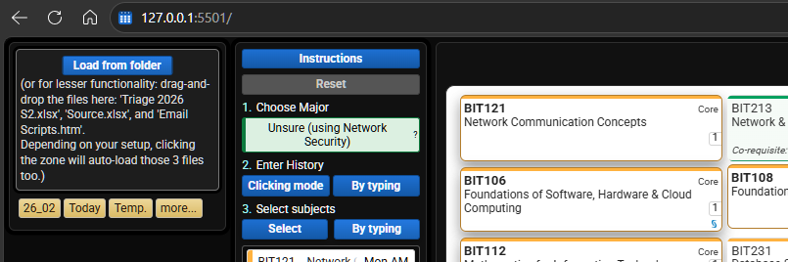

Edit settings.txt
Open settings.txt which is at the top level of the sites folder.

Profile and Intake
The most important parts for you to change are:
PROFILE=addve
INTAKE=Enrol 26_S1
Change PROFILE value to your Windows/OneDrive user folder name. This is usually the name in C:\Users\NAME\.
Change INTAKE to the current semester folder name under the Bachelor of IT Operations SharePoint General folder. Examples:
INTAKE=Enrol 26_S1
INTAKE=Enrol 26_S2

Folder Path
This line usually does not need to change.
THIS_SEMESTERS_FOLDER_PATH=C:\Users\{PROFILE}\OneDrive - Melbourne Polytechnic\General - Bachelor of Information Technology Operations\{INTAKE}\Enrolment System\
Only change this path if the Enrolment System folder is stored somewhere different on your computer.
Perhaps your OneDrive is not installed directly on C drive, and if not, you may want to change the path, but you should NOT change/delete {PROFILE} or {INTAKE} because the site replaces them using the values you enter above.

Communications Settings
This section controls your email greeting and sign-off. Change them to your preference, for example:
SALUTATION=Hello
SIGNOFF_PHRASE=Regards
SIGNOFF_NAME=Donald

Default Communications
This section is only a fallback. You don’t need to change this. It is used only if the teacher-specific COMMUNICATIONS values are missing or blank.

Example settings.txt
You can delete the comments and blank lines or leave them. These are the only important lines:
PROFILE=dmr
INTAKE=Enrol 26_S2
THIS_SEMESTERS_FOLDER_PATH=C:\Users\{PROFILE}\OneDrive - Melbourne Polytechnic\General - Bachelor of Information Technology Operations\{INTAKE}\Enrolment System\

COMMUNICATIONS
SALUTATION=Hi
SIGNOFF_PHRASE=Regards
SIGNOFF_NAME=David

Optional windows helper for folder buttons
The helper improves opening local folders and files from browser buttons.
Run this once from the site folder:
powershell -NoProfile -ExecutionPolicy Bypass -File .\install-enrol-protocol.ps1
Steps:
- Open Command Prompt or PowerShell.
- Change to the site folder.
- Run the command above.
- Reopen the website.
- Use the site help/settings option to enable the helper if needed.

Test if everything’s working
- Double-click on index.html to open the site locally (not via the web)
- Click the “Load from folder” or “Load” button and select the semester “Enrolment System” folder.
- Approve the browser permission prompt.
- Confirm the left file panel shows:
  - Source.xlsx
  - Email Scripts.htm or Email Scripts.html
  - the correct Triage workbook

Common problems
Problem | Likely Fix
Student details do not appear | Check Source.xlsx loaded, OneDrive sync is complete, and the student exists in Source.
Triage says not loaded or wrong file | Check the filename matches the expected Triage year/semester pattern, not Triage Updates.xlsx.
Folder buttons do not open folders | Install the Windows helper and enable it in the site.
Browser asks for permission repeatedly | Click Load from folder again and approve folder access.
Triage write fails | Close Excel, wait for OneDrive sync, reload the folder, then try again.
OneDrive merge conflict appears | Avoid simultaneous edits. Decide which workbook version to keep and check Triage Updates.xlsx.
Site opens, but browser tells you that you don’t have access to a file or folder permissions | Check the site was opened with Live Server (via VS Code) and that OneDrive is syncing the BIT Operations SharePoint files locally.
Triage write succeeds but Excel/OneDrive shows a conflict | Check Triage Updates.xlsx, then manually reconcile the Triage workbook if needed. Avoid having the workbook open in Excel while saving from the site.

Writing to Triage workbook
When the site is loaded, you will find see a button for writing the student’s details to the Triage.xlsx workbook.
Note that the Triage workbook writes are more fragile than normal website actions because the file is an Excel workbook stored in OneDrive/SharePoint. Best practice:
- close the Triage workbook in Excel before saving from the site
- avoid multiple people writing to Triage at the same time
- wait for OneDrive sync before trying again after a failed write
Any change you make will be written also to Triage Updates.xlsx. You can treat this as a back-up or source for double-checking additions.

